07.01
Shift Planning
Process Design & AMOS Configuration Document
Purpose
This Process Design document is provided to Key-Users to record their key decisions regarding the AMOS Process design and the required AMOS configuration.
It is updated throughout the Project Definition Phase and used as the baseline for the Final Acceptance prior to Go-Live
Revision
Author, Name | Date | Notes
FDEL | 23-05-2024 | First Version
BENX | 03-12-2024 | Flow Chart updated

Contents
1. Process Overview & Objectives 3
2. Regulatory References 3
3. Definitions & Glossary 3
4. Process Tasks 4
5. Process Dependencies 4
6. Process Flow 5
7. Process Design Questions 6
8. Data (Source) Mapping 7
9. Other Software Used 7
10. AMOS Configuration 8
a. Basic Data 8
b. Parameters 8
c. Workflows 9
d. Scheduled Tasks 9
e. API’s & Interfaces 9
11. Annex – Additional Info 10

Process Overview & Objectives

Process General Description:
This process covers the management of staff attendance starting from the definition of shift patterns to the daily variations (absence requests, shift changes, etc).
The design of the shift pattern is usually made by Human Resource department, accordingly either to the national labour regulations and the business lines’ needs.
The update of the shift plan is managed by the Production Shift Leader according to the staff requests and/or the workload demand.
A dedicated interface (TRANSFER STAFF AVAILABILITY) can be used to Import / Export Staff Availability to / from the Shift Planning module with an external HR software to avoid duplicating the entries into two different systems.

Main Process Objective (Outputs & Outcomes) :
The main purpose of this process is to have a constantly updated staff attendance overview, to be used for the Capacity Planning in conjunction with the production workload.
The updated shift plans feed all the relevant modules dedicated to Capacity Plan and resource assignment:
- Resource Overview (APN:711)
- Resource Planning (APN:2323)
- Line Maintenance Manager (APN:2950)

Regulatory References

- EASA AMC1 145.A.47(b) Production Planning
- ICAO document 9824- Chapter 3, Appendix H

Definitions & Glossary

Key-Words | Explanation
Entry Type | Code used to create the shift pattern or to justify an absence ( for example Early Shift, Night Shift, Holiday, Sickness, etc.)
Shift Pattern | A shift pattern can either be a basic one, simply defining the starting/ending time for an Entry Type or a Combined where several basic Shift Patterns are combined into a shift plan. This shift plan has not specific start date yet.
Shift Group | Group of staff associated to a shift pattern
Group & Team | Groups & Teams are “containers” where you can assign staff based on specific duties, qualifications, departments, even if they belong to different shift groups.

Process Tasks

Main Process Task / Actions / Activities:
The following actions are performed in this Business Process:
- Create the Entry Type in APN 990
  - Define name, short code, colour.
  - Set a Code Mapping in case an interface is needed to import/export data from/to an external system, by creating a mapping between AMOS Short Codes and other program codes.
  - Define the manpower category (Absence, HR info or Shift).
The Manpower calculation is based on the 4 flags:
    - Produce Manpower (Shift, Overtime)
    - Maintenance Planning Context
    - Office Planning Context
    - Reduce Manpower (Break, Holiday, Sickness)
- Define the Shift Pattern in APN 974
  - Identify the Basic shift Patterns (for example Early, Late, Night, Off, etc.). To have more flexibility it’s suggested to create basic patterns with the length of 1 day.
  - Create a Combined Shift pattern built by a sequence of different Basic shift (for example 5 Early, 2 Off, 5 Late, 2 Off)
- Create Shift Groups in APN 978
  - Define Shift Groups associated to Stations/Departments
  - Define the Shift Leader, assign staff to each group and define the start date.
- Generate the Shift Plan: Shift plans must be re-generated with a certain frequency (usually every 3 months to once a year). To be considered before re-generation: possible team changes and re-organization, Shift Pattern changes, Shift Pattern approval. Shift plans can also be generated in groups, by selecting multiple shift groups.
- Based on the workload needs or staff requests, the shift plan can be adjusted in APN 1024. Any mechanic can use APN 979 (Staff time Management) to view his own plan and issue requests for holidays, overtime, shift change, etc.
- For large organizations, there is the chance to create Groups and Teams and to assign vehicles to them with APN 4046. Moving staff from one team/group to another is straightforward (drag’n’drop). This movements have no impact on the attendance, but they are reflected at capacity level since in all Capacity Plan related APNs, staff can be filtered based on Groups and Teams.
- Interface can be set-up to send/receive staff attendance data from/to an external system.

Process Dependencies

- 07.02 – Hangar & Resources: Staff Information come from this process, where employees are created in the system.
- 07.05 – Resource & Staff Allocation: Staff attendance is the main source for Capacity Plan regarding the manpower availability.

Process Flow

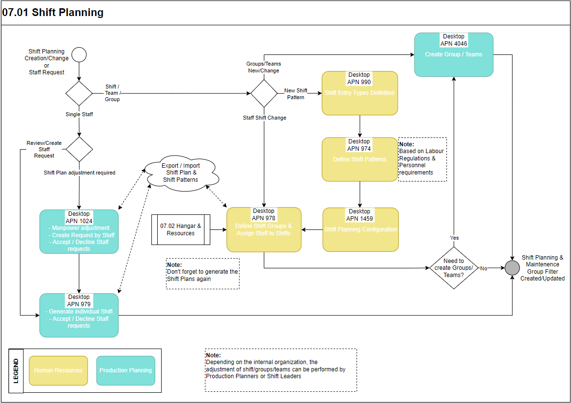

Process Design Questions

# | Question | Answer
1 | Which is your current logic of labeling shifts? Can this logic be applied to the AMOS logic of Entry Types?
2 | In case of an interface setup, which system will be used as “master”? HR system or AMOS?
3 | In case AMOS will be the master system for managing shifts, do you want to implement Labor Regulations to control shift planning infringements (e.g. Minimum rest not observed, Maximum days on duty / days off in a row)?
4 | Describe your current shift planning process:  - who defines the shift patterns  - who manages the shifts  - how are shift changes requested by mechanics  - how are shift changes communicated to mechanics
5 | For what purpose do you want to use Shift Planning?  HINT: Shift Planning could be used for having the Manpower Availability in AMOS up to reporting confirmed attendance time to a payroll system.
6 | Do you differentiate Line Maintenance Resources from Hangar Maintenance Resources? How? Can they be mixed?
7 | Do you have shops? Does shop resources be considered in the Shift Planning? Can they eventually work in the Hangar or Line shift groups?
8 | Do you need an approval of the shift pattern? Is it enough an approval of the shift pattern or the actual shift plans for a certain period of time have to be approved?

Data (Source) Mapping

Data Sources | Description | Volume / Manual / Automatic / Static / Dynamic
-Nil-

Other Software Used

Other Softwares | Used by: | Description
-Nil-

AMOS Configuration

Basic Data

Basic Data Table | Notes
Maintenance Calendar | This table stands to define a high-level representation of common shifts groups dedicated to the maintenance. The standard definition is a sequence of Early, Late and Night shifts.
Vehicle | This table stands to define an high-level representation of Vehicles than can be assigned to groups/staff

Parameters

Parameter Code | Parameter Name | Notes
1885 | Maintenance Calendar Time Zone | Use this parameter to define the time-zone of the Maintenance Calendar Entries defined in the Program "Basic-Data Administration".String value (default = empty = AMOS Server`s time-zone) | -
1422 | Qualification Visible | This parameter defines the qualifications visible in the popup menu "Qualifications" used in the different programs of the Shift Planning module. This popup menu is displayed when selecting a user sign. The qualifications are defined in PQS Basic Data as Event Classes
1404 | Use Shiftplan in Planning Modules | With this parameter you can control if the shiftplan taken from the AMOS shiftplanning modules should be used to calculate the availability of human resources or not.  If set to "Y" you will see the shiftplan in ResourceManagement module for all human resources. If you don`t use the AMOS shiftplanning modules you should set this parameter to "N". | Y

Workflows

Workflow Number | Workflow Name | Notes
380 | Shift Plan Modification | This workflow is triggered before a Shift Plan is created, modified or deleted. Please be aware that this workflow can be configured in a way that it can prevent the execution of the action.
88 | Staff Request (Creation) | This workflow is triggered, when a Staff Request is opened for an employee
89 | Staff Request (Review) | This workflow is triggered, when a Staff Request is reviewed (e.g. Accepted or Declined)
90 | Shift Plan Modification | This workflow is triggered, when a modification is done on the Shift Plan of an employee
160 | Staff Request Reminder | This workflow is triggered, when a Staff Request has not yet been administrated for an employee
166 | Clock-In / Clock-Out | This workflow is triggered, when an employee clocks-in or clocks-out
171 | Entry Type Creation | This workflow is triggered, when an Entry Type is created automatically from a Staff availability import.
178 | Attendance Review Process | This workflow can be triggered with the Attendance Review process, either by the Time Keepers, the Employees or the Time Controllers

Scheduled Tasks

Scheduled Task Reference | Frequency | Notes
ShiftPlanning_HumanResourceManagementService
StaffRequestReminderService | Daily | Check Staff Requests opened since x days

API’s & Interfaces

Reference | Direction | Trigger | Frequency
TRANSFER STAFF AVAILABILITY | Import / Export Staff Availability to / from the Shift Planning
TRANSFER BOOKING | Import/Export staff time booking

Annex – Additional Info

-Nil-

